1.

a) I did something, not sure if it’s right. I took log base 2 instead of ln because it gave easier values to work with.

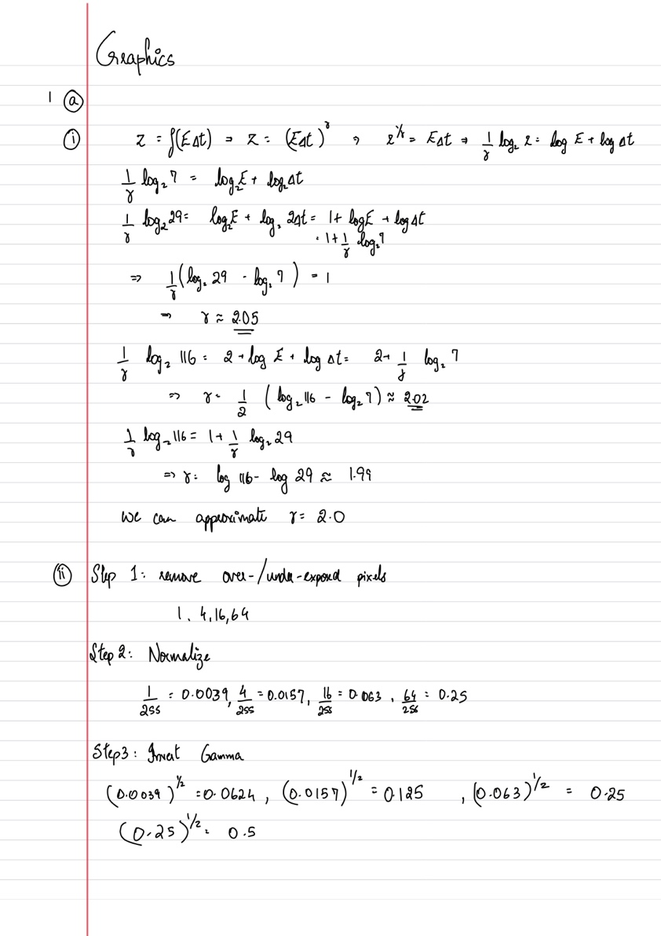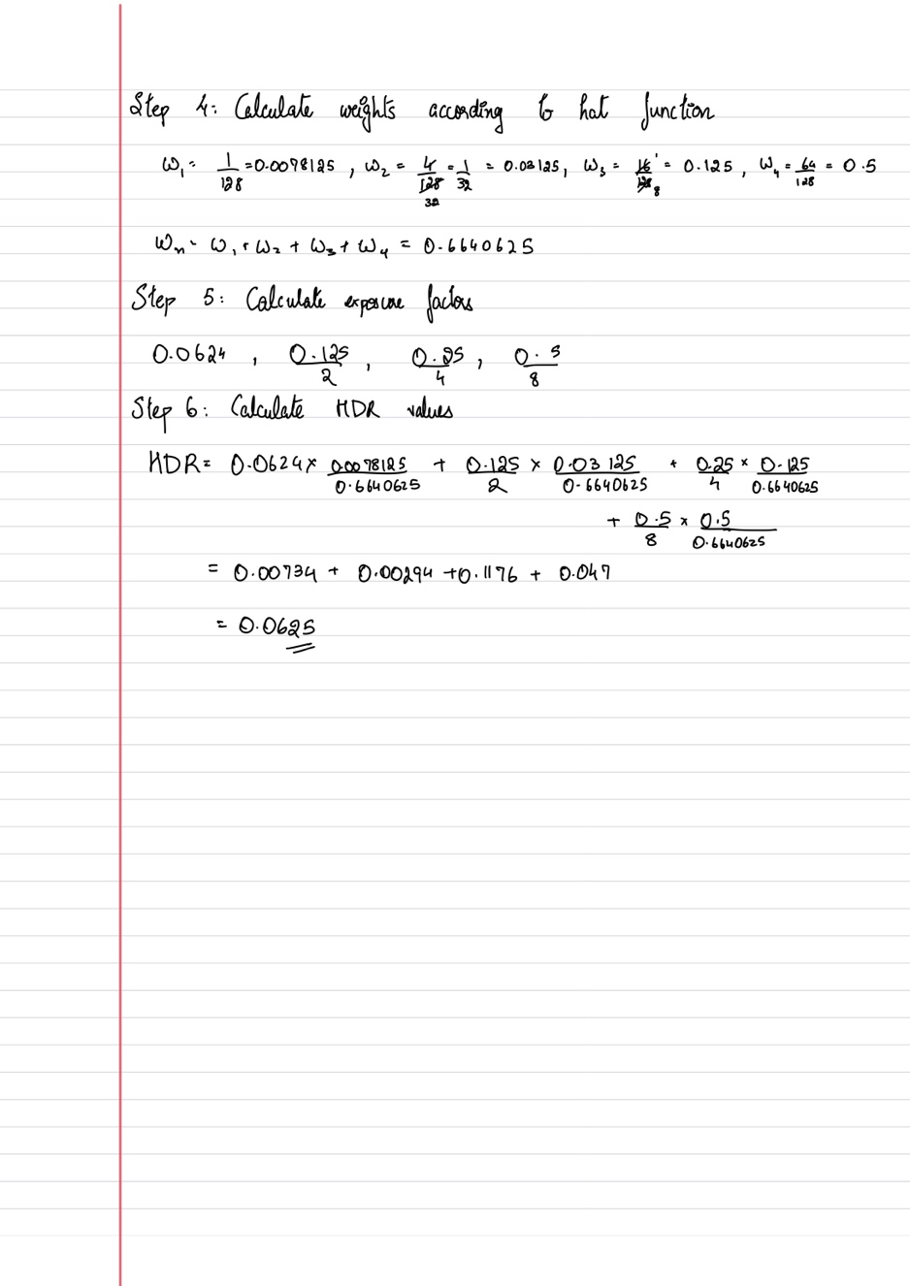

b) The .PFM format stores 32-bit values for each color channel in each pixel of the image. These values have 1 bit for the sign, a few bits for the exponent and the rest are the mantissa. It is a very expensive format.

The .HDR format stores only one 32 bit value for each pixel. It allocates 8 bits each for the R,G,B channels and the exponent. It cannot store negative values as it was initially designed for radiance values, which are never negative.

i) (150, 210, 100) * 2 ^ (150 – 128) = (629145600, 880803840, 419430400)

ii) (200, 110, 140) * 2 ^ (110 – 128) = (0.00076, 0.00042, 0.000534)

.EXR can store more detailed lighting information, as well as represent situation where the per-channel intensities are very different. (Each channel has own exponent)

c) Tone mapping remaps the floating point HDR values to 0-255 range so that they can be viewed on a screen or printed, etc.

Automatic remapping – linearly remaps the values to 0-1, then to 0-255. A disadvantage of this method is that it produces very dark images.

Histogram Equalization – This method remaps the values more evenly across the bins in the 0-255 range. It achieves this by stretching and scaling the original intensity bins that are very unevenly distributed. It is typically performed on the intensity channel in the LUV or HSV space. The colour information is then added back after equalization.

User-driven tone mapping – in this method, synthetic exposure bracketing is done after remapping the values. The user manually changes the exposure by one stop until they get a satisfactory image. It is a user-driven, subjective process.

Color is preserved by gamma reduction. In most methods the color information is removed before tone-mapping and added back after.

Local tone-mapping is used to preserve local contrast by preserving edges/details. It is usually combined with global tone mapping.

Flowchart – Lec 3 slide 25

Step 1: Preprocess image by e.g. removing the color information – get processed HDR image.

Step 2: Apply an edge preserving filter e.g Bilateral, trilateral, etc to the processed image to get the base illumination layer.

Step 3: Subtract the base layer from the processed HDR to get the detail layer, which holds information about the reflectance of the image.

Step 4: Apply a global tone mapping operation e.g. histogram equalization, etc to the base layer to get a compressed illumination.

Step 5: Add the information in the compressed image to the detail layer obtained in Step 3 to get the tone-mapped image.

Step 6: Add back the colour information and perform any other required post-processing to get the final LDR image.

d) https://vgl.ict.usc.edu/HDRShop/support.php has a tutorial xD

A light probe is acquired by photographing a mirror ball, and then mapping them into any probe map format. At minimum, 1 viewpoint is required, and we simply map the photographed mirror ball to a cube or latitude/longitude map format. Ideally, we want 2 viewpoints 90 degrees apart as they would have sufficient overlap that allows us to merge the images easily for a higher resolution output, as well as to remove undesirable elements (eg. View of photographer)

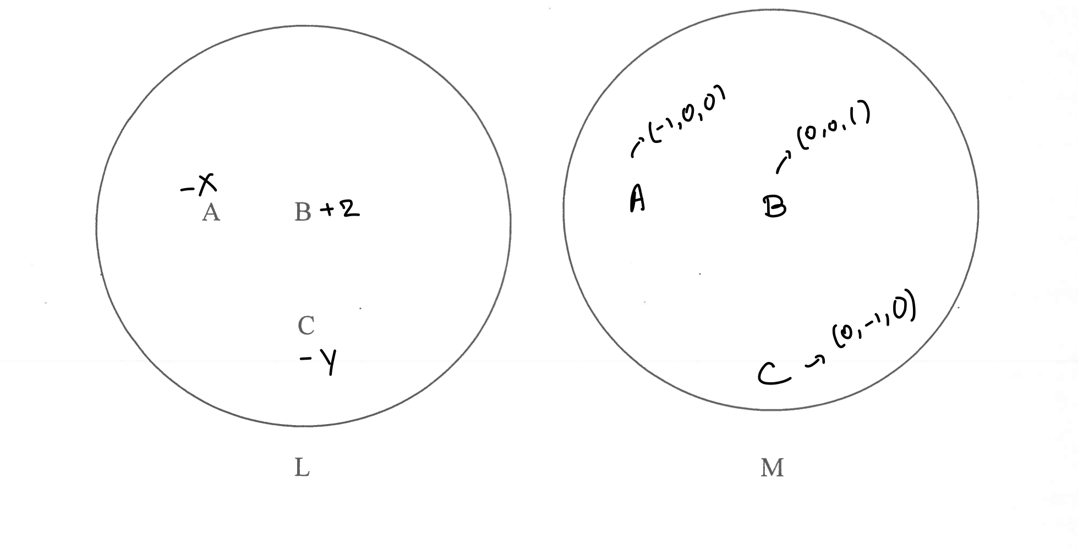Angular map points are evenly spaced, Mirror ball points are squished in the front and stretched in the back.

N_a = (-1/sqrt(2), 0, 1/sqrt(2))  
N_b = (0, 0, 1)  
N_c = (1, -1/sqrt(2), 1/sqrt(2))

2)

a)

Reciprocity – Given a camera and a light source, whatever reflection intensity is seen by the camera would be seen if the camera and the light source positions were swapped.

f_r(x, omega_r, omega_i) = f_i(x, omega_I, omega_r)

Energy conservation – Extra energy isn’t created. All the energy has to be emitted from some light source. So for reflection, the surface can only reflect <=1x the amount of light it receives and never any more.

Reflection is recriprocal but transmission is not. Reciprocity requires that if incidence and reflected rays are switched, then total surface reflectance observed doesn’t change (Light does not preferentially travel in one direction compared to another). This is not possible in transmission, as the refractive indices determine factors such as amount and direction of light transmitted, so if the rays were switched then the values would change. On the other hand, reflection is dependent only on angle of incidence, which will be same if positions are swapped and thus maintains recriprocity.

Reciprocity means that the reflection measurements repeat so that values at phi and phi+pi will be the same so you only need to store half the measurements.

With a diffuse sphere and a laser, you can observe and record the reflectance of an object. The camera records the reflectance rather than the object. This increases measurement quality as we can now take continuous, rather than discrete measurements.

b)

eta = 1.5

Brewsters angle = arctan(1.5/1.0) = 56.31

Schlick’s approximation R = 0.05680868552

T = 1-R = 0.9431913145

Theta_t = 33.69 using Snell’s law

Then R_perp = 0.1479

C)

The GGX distribution has a longer tail and a sharper peak compared to the Beckman distribution. This is better suited for measured materials because the Beckman distribution falls off too quickly which is not seen as often in real world materials.

The half vector parameterisation has the advantage that the specular highlights become symmetric about the half vector and that the BRDF matrix goes from being full rank to low rank. This means we can do less measurements via non-linear sampling, and preferentially sample around the half vector.

The information in the MERL database can be treated as a set of ‘basis functions’. We can represent any new material in terms of those ‘basis functions’, whether they be the principal eigenvectors of a PCA on the MERL matrix, or the actual per-material vectors.

D)

Theta_B = arctan(1.4/1.0) = 54.462

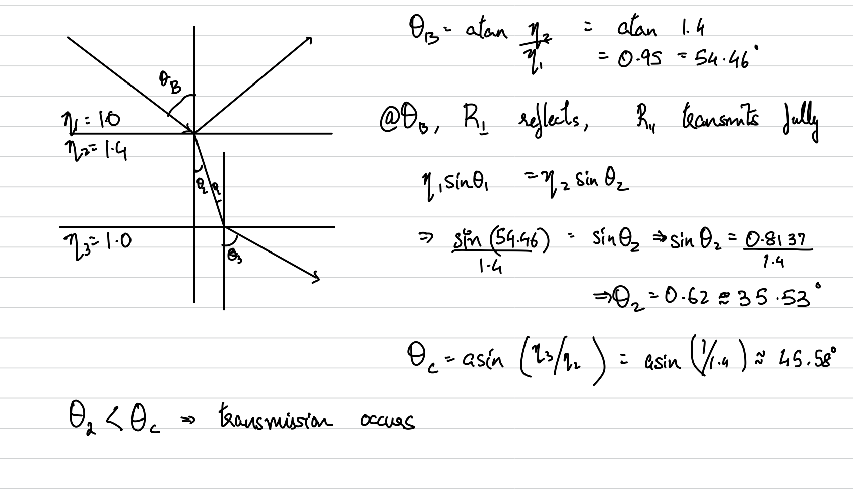

3.

a) Step 1: Calculate CDF by integrating over pdf p(w_h)

Step 2: Invert CDF

Step 3: Draw uniform random values between 0, 1 = u

Step 4: Project inverse cdf on random value -> C^-1(u) = x, x is the r.v.

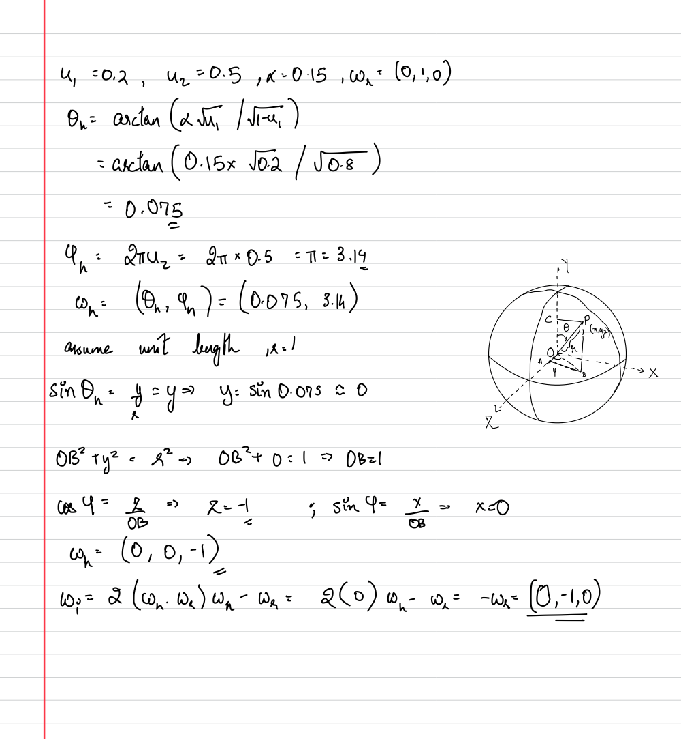

B) Bound the product distribution with the product of max of the BRDF function with the Illumination distribution. To sample, we generate a random sample from the proposal distribution and then a second random number which we then scale by f_max * q(l). Now we need to check if this generated sample is actually in the target distribution or not. If it isn’t then we reject and sample again. (diagram – Slide 18, Lecture 10 – Sampling Direct Illumination)

With sampling importance resampling, we generate a large number of samples in the first stage from one of the distributions, say f and then create a look up table by sampling the illumination at those directions. In stage 2, we create another 1d pdf based on the value of the illumination and generate a smaller second set of samples based on the intensity of the illumination. The directions from the second step are then used for raytracing.

Acceptance = 0.7/(5*0.4) = 0.35

C)

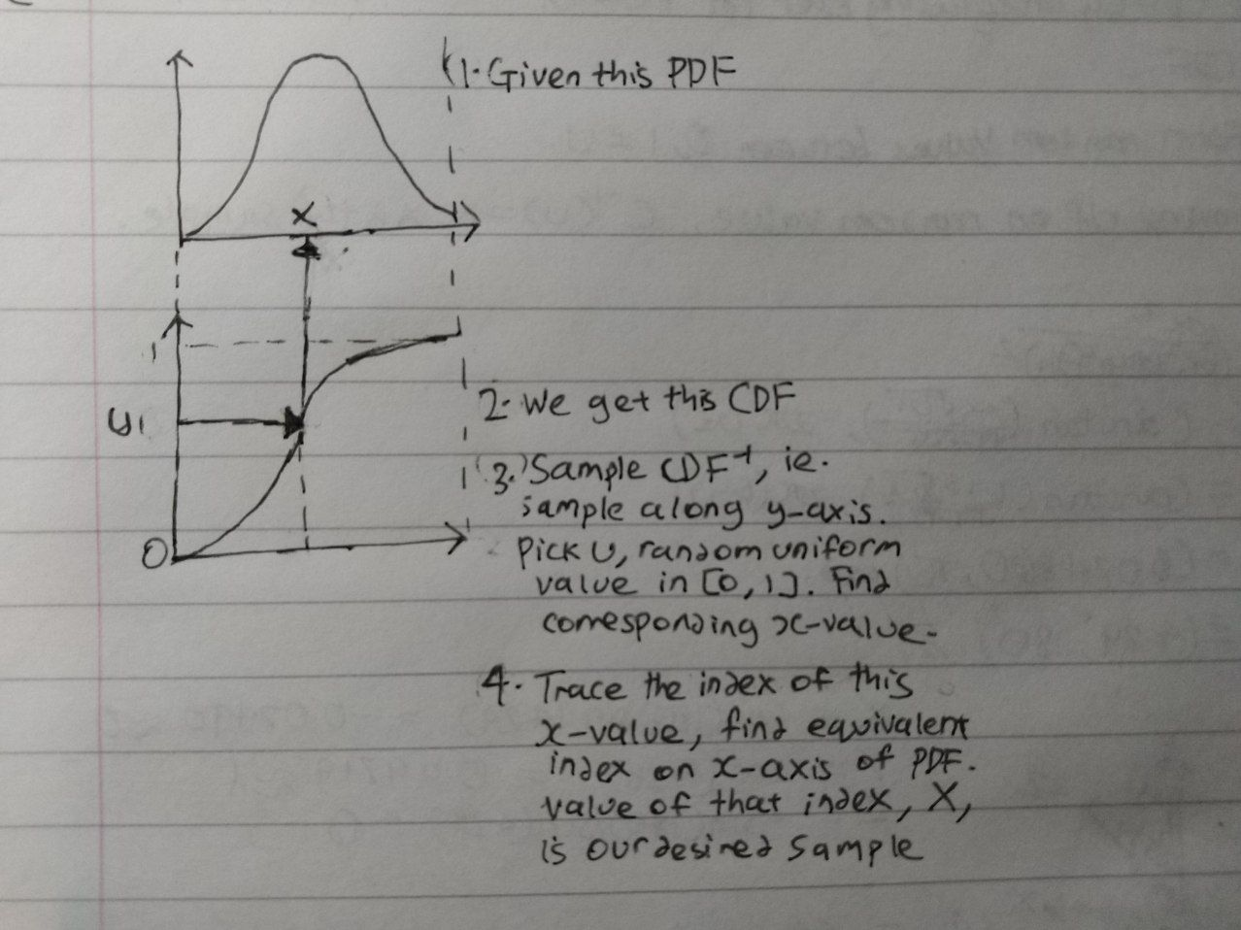

You can use the technique to sample from an EM by calculating the PDFs and CDFs of the rows and columns and then sampling points from there. Most of the samples will fall in the bright parts which is what you want.

Total = 200

Pdf = 0.05, 0.125, 0.15, 0.1, 0.075, 0.075, 0.175, 0.05, 0.1, 0.1

Cdf = 0.05, 0.175, 0.325, 0.425, 0.5, 0.575, 0.75, 0.8, 0.9, 1.0

u1 = 0.75 => index 7 => 35

u2 = 0.3 = > index 3 => 30

u3 = 0.9 => index 9 => 20

D) Reflected radiance = 100 * (0.5/pi) * (0.5/pi * 0.1^2) = 253.30

Photon density = 100/pi * 0.1^2

200/(pi * 0.1^2) = 6366.19 or should this still be 100

dR(x) = 0.1 - 0.1 * (sqrt(125/200)) = 0.020943

d'(x) = (125)/(pi * (0.1 - 0.020943)^2) = 6366.19

Using the formula in the slides I got 6366.19 again as the density when the radius is reduced

Not sure about matrix row-col sampling (No longer assessed)

4)

a) alpha = sigma_s/sigma_t = 0.7

Sigma_t = sigma_a + sigma_s

Solve to get sigma_t = 2/3

Then use Beer’s law T = exp(-sigma_t * d)

T = exp(-2/3* 0.35) = 0.7918895663

Directional dipole is no longer assessed. Paper if interested => https://dl.acm.org/doi/10.1145/2682629

B)

R_12 = 0.40426, T_12 = 0.5957

T_123 = 0.4473

R_123 = 0.473

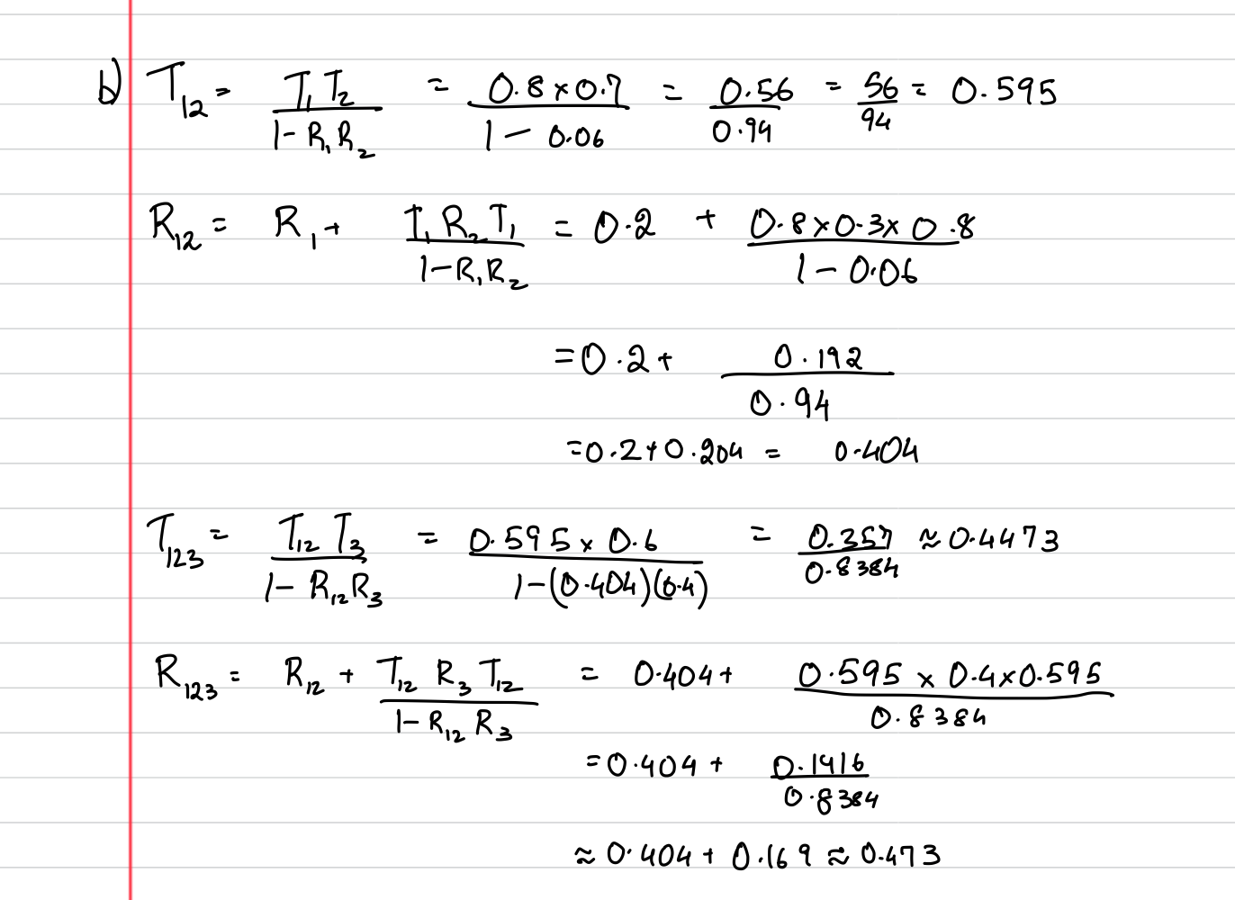

The Marschner model is better because it models single scattering of light which gives rise to both white and brown reflections(secondary highlights) in dark hair. Also models hair strand with surface roughness and not just a cylinder (so more realistic).

C)

Light arc – Advantages: Don’t need a rope and pully system like the original light stage design. Not as much of a manual process. Also much faster to actually measure because you don’t need to pull the light source around.

Disadvantages: Only really works for small scenes. Otherwise you need a massive rotating arc or a massive turntable, both of which are not practical.

LED sphere – Advantages: No turntable needed. No moving parts. Good for human subjects because you can capture all angles at once and they don’t need to keep still for long like in the other method.

Disadvantages: Expensive because you need a lot of lights. Complex. Not as of an angular high resolution because you have a fixed number of lights usually in the hundreds.

Free-form light stage - Advantages: Very cheap. No need for complicated and specialist equipment. Handheld light source such as a mobile phone is enough.

Disadvantages: Don’t know where the light source will be ahead of time. Need to calibrate using spheres. No longer have uniform sampling. It is free form which makes it more complicated to actually relight your objects.

Linearity of light transport.

The dual light stage exploits Helmholtz reciprocity. Advantages: No more aliasing effects from sharp specular reflections like you get with a LED sphere. Continuous instead of a discrete set of lights.

Continuous shadows and caustics unlike the “jumpy” caustics like with a discrete light sphere.

Disadvantages: dual light stages use powerful lasers, that are dangerous to organic materials. Cannot capture living organisms.

D)

Catadioptric systems typically use some sort of mirror/camera system. Some use concave or convex mirrors and others use a hemispherical mirror. Depending on the angles of incidence, different angles of reflection will be created and each one creates a different radial line. Speeds up measurements by allowing you to capture the results of various angles of incidence in a single photograph.

For specular reflection, the reflection vector is the 1st order statistic and the specular roughness is the 2nd order statistic. These two numbers can be used to fully describe the specular reflection of an analytic BRDF model. This is efficient because we don’t need to do dense measurements and we only have to store the parameters. Second order SH can be used to create the lighting patterns/gradients needed to directly capture the specular normal and roughness. Additionally, using SH allows us to create rotated versions of the SH using just a rotation matrix on the individual basis functions. Higher order SH are needed to capture high frequency functions and by going to order >= 3 we only get a specular response and not a diffuse one. Allows you to separate out the diffuse and specular components.